**DETAILS OF THE TEAM MEMBERS :**

PARTH JARDOSH 9987140311 Sardar Patel Institute of Technology

SHLOKA SHAH 9699608650 Sardar Patel Institute of Technology

**NAME OF THE PROJECT**:SEGRO

**PURPOSE OF THE PROJECT:**

In India mostly waste segregation is dependent on human labour.By designing such model we can foster the process of waste segregation. The problem with the manual system is they can visit places only once or twice a day and thus the waste keeps piling up leading to the spread of various diseases. With such a model we can easily send the segregated waste for recycling.

**IDEA / APPROACH TO SOLVE THE PROBLEM:**

There are mainly three sections to the idea:

#### **Smart Bin:** Bins which detect which type of waste is being added and automatically segregate them into their appropriate section

#### **Optimized Waste Collection:** Optimised Collection algorithm is used so that waste from many areas can be collected in the minimum possible time and waste.

#### **Industry:** The segregated waste will be recycled in our industries and be made into raw materials for reuse.

**Stage 1**

In this stage , as a waste article is pushed into the dustbin, the dustbin itself segregates the article into one of the different categories which have been previously decided. This helps to keep different types of wastes separate and also eliminates the need to have manual labor for the same purpose.

**Stage 2**

In this stage, trucks pertaining to each type of waste will go and collect the waste from each dustbin whenever that dustbin is ready.

What is " Dustbin is ready " ?

Whenever a particular bin has waste above it's predetermined threshold then it will send a signal to the control room stating that the waste in it should be collected in a while. When many bins in a particular area are ready to be collected then the truck pertaining to that type of waste will be released. The optimization algorithm will be used so that the truck spends minimum amount of time and fuel in the waste.

**Stage 3**

After collecting the waste, the truck reaches its particular recycling plant's location. This ensures that the correct type of waste reaches the correct recycling plant. Here the waste is recycled and used to make different types of products. All the collected waste is remade into the same so that they can be used again.

#### **Stage 4**

#### In this stage, the recycled item are sent to special markets , so that people can buy them and contribute their part in sustaining the environment.

**Technology Implemented:**

**For the Website:** The website is made using HTML5, CSS3 , Bootstrap and Font-Awesome. It is a static page which is hosted on GitHub pages [here](http://shlokashah.github.io).

**For the Machine Learning Algorithm:**

Image Classifier using CNN model ResNet34 pre-trained on the ImageNet database. Libraries like Fastai, Pytorch are used.

**For the Optimisation algorithm:**

Traveling salesman algorithm is used to optimize travel and fuel costs of the trucks.

**Screenshots:**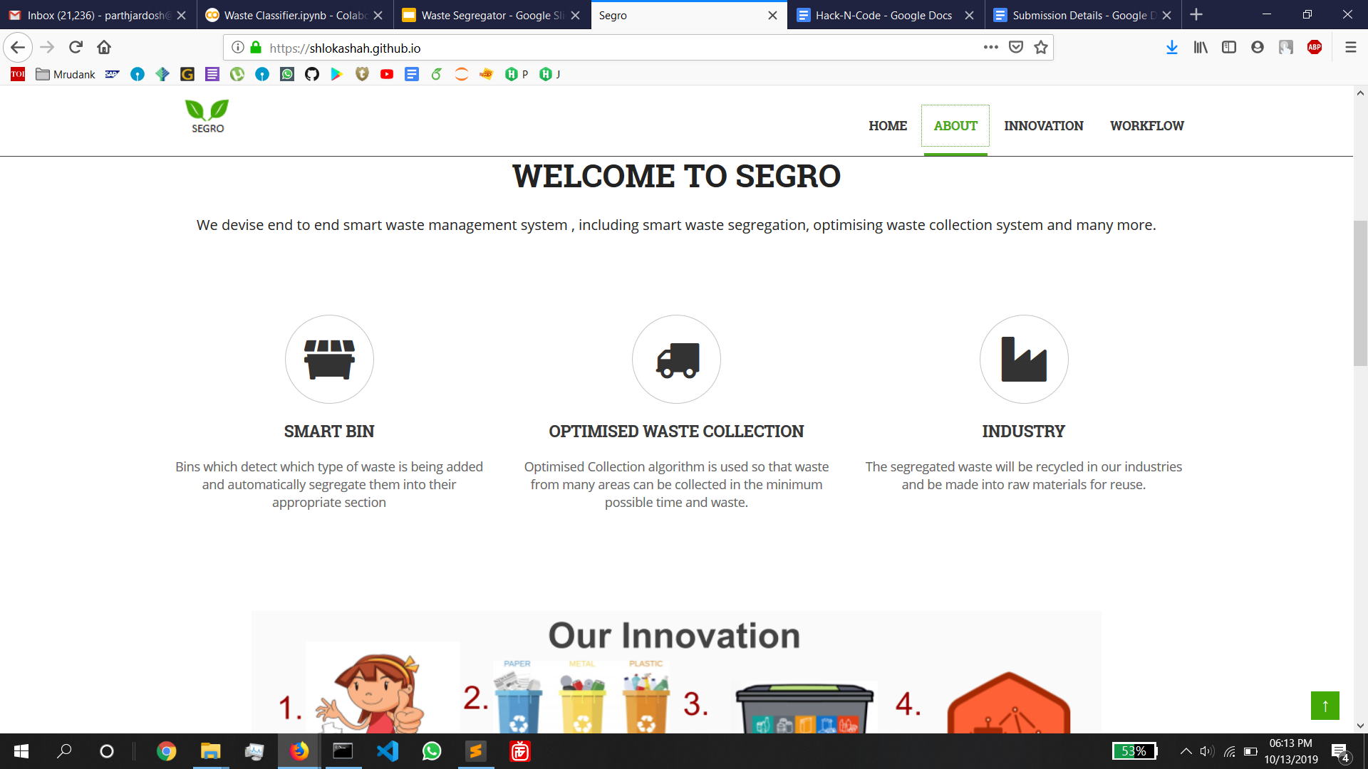

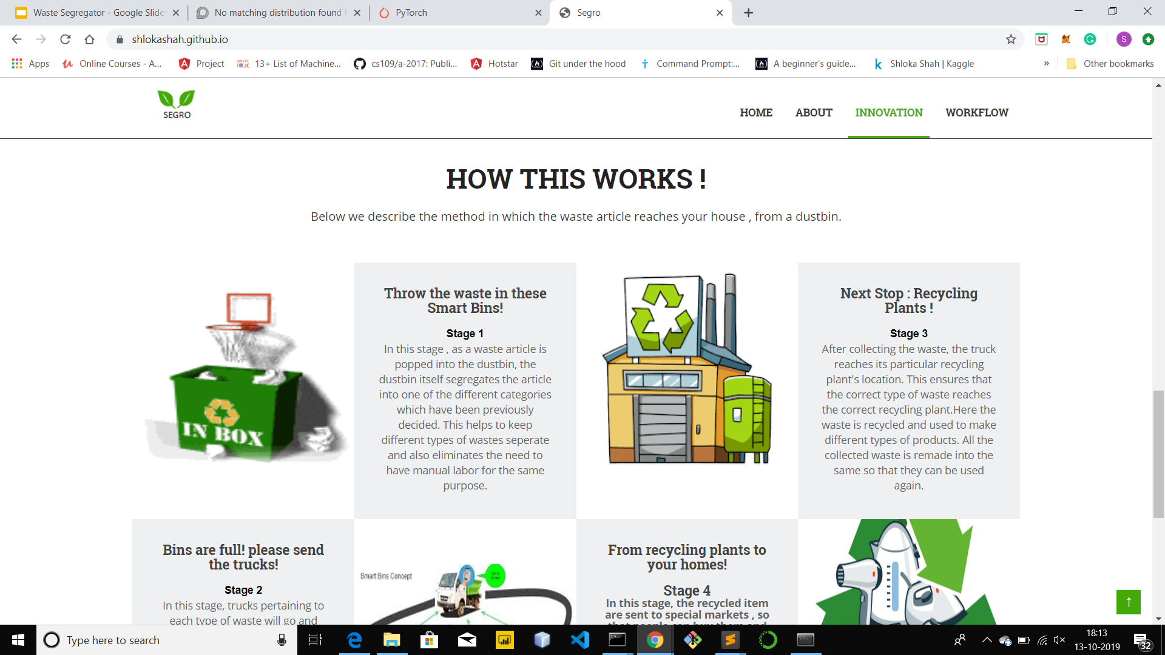

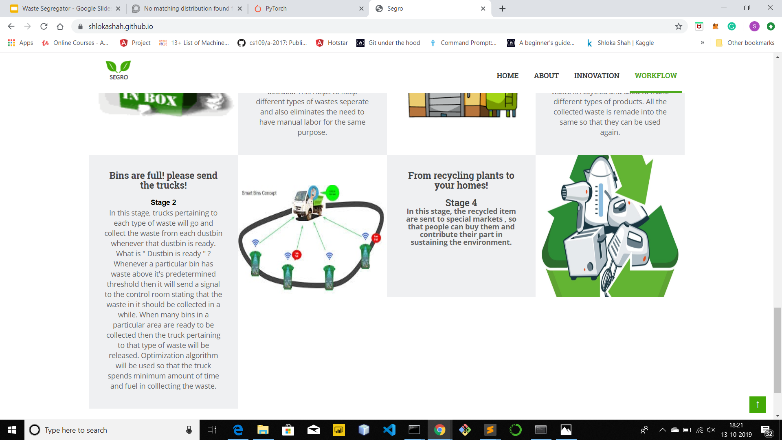

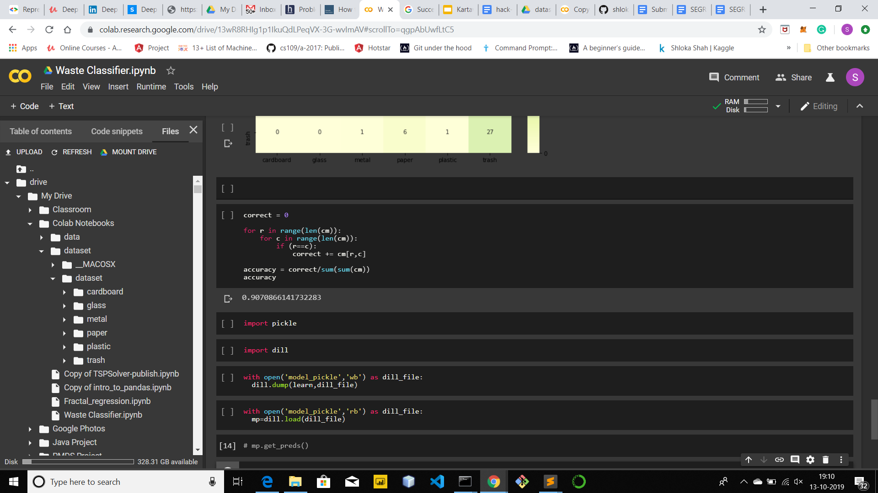

The code for the same can be found on this [github repository](https://github.com/shlokashah/shlokashah.github.io.git) under the branch Master.

**Future Scope and Scalability:**

This idea can be implemented on a large scale for which a large number of hardware devices and a few modifications to the existing garbage bins would be needed. The software part would need to be scalable for which the entire system can be made using Django, since it is highly scalable. As a part of future scope, the threshold of every bin can also be made dynamic, depending on various conditions, like traffic situations, roadblocks etc, which can increase the time taken by the truck to reach the bin and thus cause overflowing of the bin.